***OBJECTIVE:*** To study protection of Induction Motor using numerical relay.

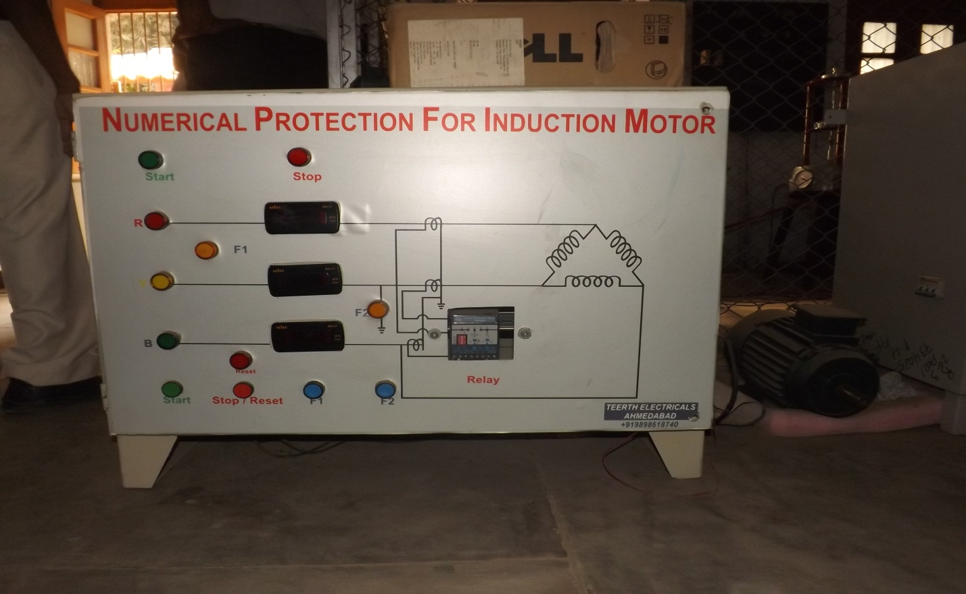

***EQUIPMENT REQUIRED:***

* Three phase induction motor
* CTs
* Numerical relay

**Circuit Diagram**

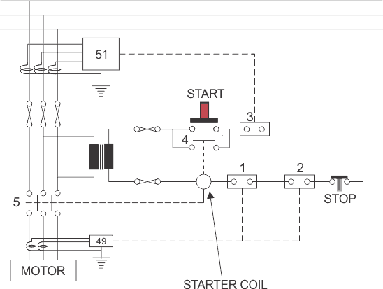

***THEORY:***

Thethree phase induction motors are very reliable and robust, modern designs operate much closer to the limits of thermal margins and to give adequate protection, sophisticated protective relays are required. In addition, increased industrial use of power electronics leads to incorporate different harmonics in the system, which adversely affect the induction motor performance and cause considerable rotor heating.

The numerical relay has been designed to protect the motor against these phenomena as well as known abuses such as mechanical overload , stalling and locked rotor, sort circuit , earth fault , phase unbalancing , single phasing , terminal box and cabling failures , and too frequent starts .

The term single phasing means one of the phase is open. Tis condition subjects the motor to the worst case of voltage unbalance. The phase current will increase by √3 times. Noting can prevent or eliminate single phasing.

A numerical relay is a solid state relay also called static relay. It contains electronic circuitry which may include transistors, ICs, diode and other electronic components. There is a comparator circuit in it, which comparing 2 or more voltages or currents gives output applied to either a slave relay or a thyristor circuit.

The slave relay is an electromagnetic, semi static relay which closes its contacts .The numerical relay as low burden on CT, PT, fast operation, absence of mechanical inertia and contact trouble, long life and less maintenance. So, they are superior to electromagnetic relay, but they are costly and required more maintenance.

***WORKING AND OBSERVATION:***

There are mainly two types of faults on Induction Motor.

1. **Winding – Winding fault:**

This mainly occurs due to insulation failure of stator winding. This type of fault results in imbalance current between two phases. This imbalance current is then served by numerical relay to cause the trip of supply.

1. **Winding – Earth fault:**

When a winding is earthed due to some reasons like insulation failure, ten voltage drop is very fast but current increases. This is a dangerous situation and this imbalance is sensed by the numeric relay which trips the supply of motor.

***RELAY DETAILS:***

The Motor Protection Relay (MPR30) is a tree phase LT motor protection relay for motor sizes up to 50KW (max. 88A current). It is a low cost solution, offering five major protections for motors widely used in fans, pumps, crushers, mills, compressors, belt conveyers, centrifuges, mixers, ventilators, escalators, motorized valves etc. Major advantage is that it provides E/F coordination in contactor-started motors, thus offering greater security, operator safety and economy. The relay is micro-controller based, highly user friendly and compact with inbuilt CTs. The relay can also be used for protection of larger motors by using external CTs.